Design a window interface with a frame, two Text Fields, and two buttons (Figure 1). When the user clicks on the red button the background color of the left Text field turns to red and the one on the right turns to white (Figure 2). On the other hand if the user clicks on the blue button the background color of the right text field turns to blue and the one on the right turns to white (Figure 3).

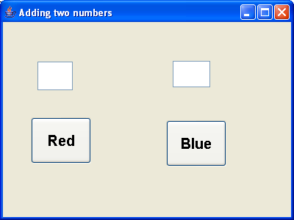

Figure 1. The initial state.

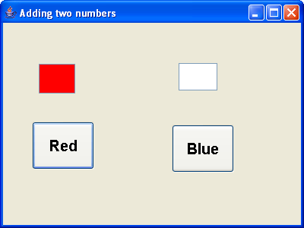

Figure 2. When the user clicks on the red button.

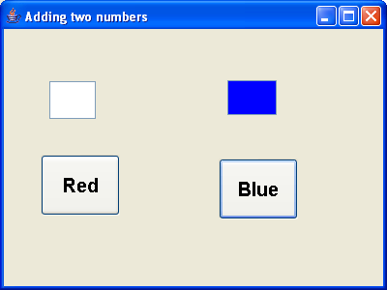

Figure 3. When the user clicks on the blue button.